

**Faculty of Engineering & Technology – Electrical & Computer Engineering Department**

**First Semester 2022 – 2023**

**Circuits and electronics lab**

**ENEE2103**

**PRELAB EXP.10**

**Name: Amal Ziad**

**ID: 1192141**

**Section: 2**

**Instructor: Dr. Mohammad Jehad Al Juba**

**TA: Eng. Yazan Yousef**

**Date: 1st Jan 2023**

# Adding application

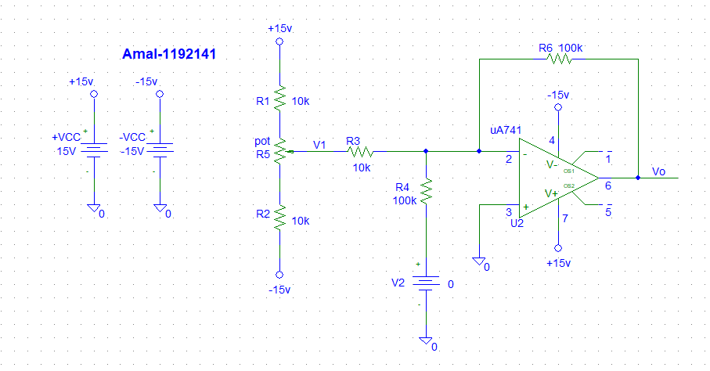

* (v1,v2)=(0.5,2) when the potentiometer set is 413m to get voltages v1= 0.5v

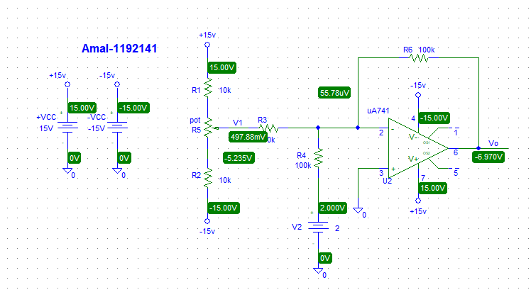

* (v1,v2)=(0.1,6) when the potentiometer set is 482m to get voltages v1= 0.1v

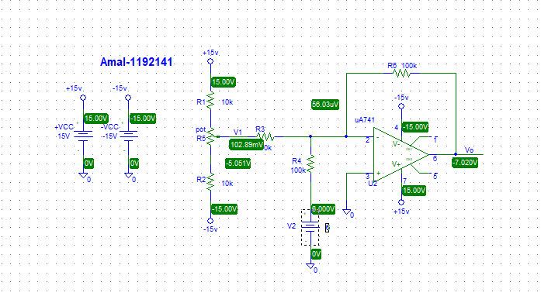

* (v1,v2)=(0.3,4) when the potentiometer set is 447m to get voltages v1= 0.3v

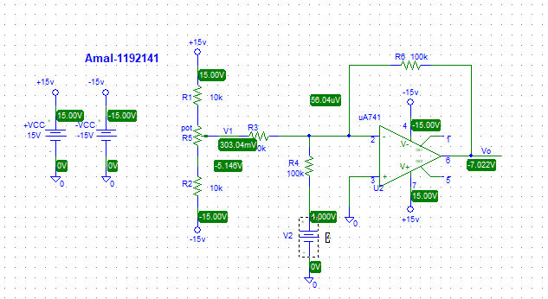

* (v1,v2)=(-0.9,2) when the potentiometer set is 657m to get voltages v1= -0.9v

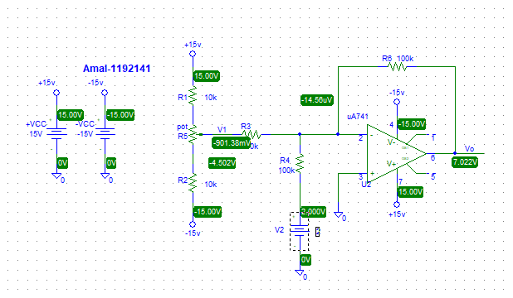

* (v1,v2)=(-1.1,4) when the potentiometer set is 691m to get voltages v1= -1.1v

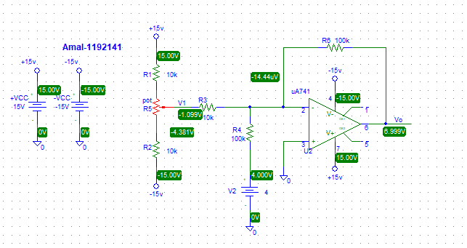

* (v1,v2)=(-1.5,6) when the potentiometer set is 759m to get voltages v1= -1.5v

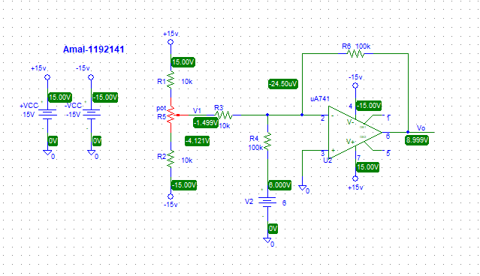

* The calculated voltage is found using the formula Vo=XV1+YV2 , where X and Y is the resistor ratios:

So the formula will be Vo = 100k/10k V1 + 100k/100k V2

Vo = 10 V1 + V2

So for V1 = -1.1 ,V2 = 4 :

-1.1(10) + 4 = 7

Another same as .

* Measure the output voltage for V1, V2 as shown in table1:

Table 1:v output to adding

|  |  |  |  |
| --- | --- | --- | --- |
| Input voltage | | Output voltage | |
| V1 | V2 | Vo | Calculation voltage |
| 0.5 | 2 | -6.970 | -7 |
| 0.1 | 6 | -7.020 | -7 |
| 0.3 | 4 | -7.022 | -7 |
| -0.9 | 2 | 7.022 | 7 |
| -1.1 | 4 | 6.999 | 7 |
| -1.5 | 6 | 8.999 | 9 |

# Voltage Follower Application:

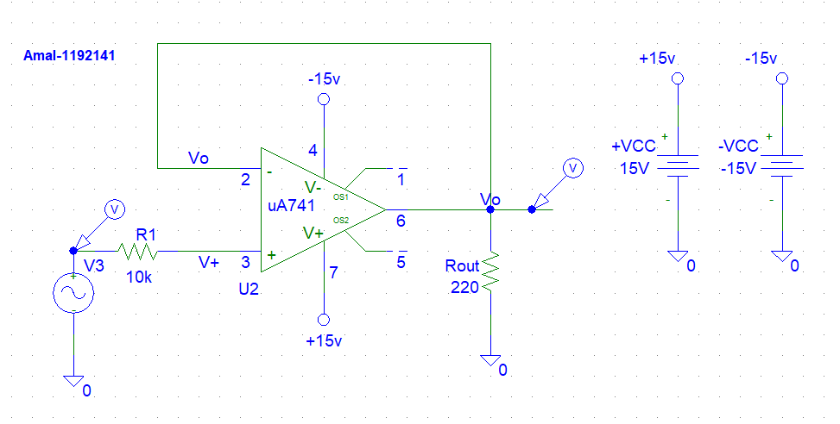

* Draw the output Vo (t) for Vi(t) is 2V p-p sinusoidal with 100Hz.



* Then Vo is measure for the following Vi as show table 2:
* For example as Circuit when vi =6V:

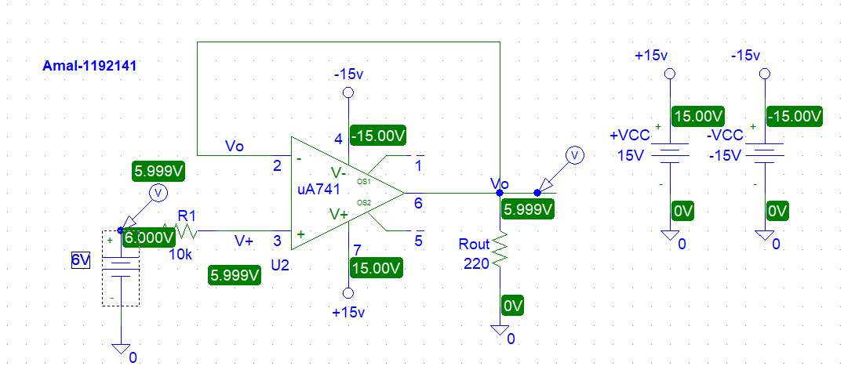Table 2 vout value of voltage follower:

|  |  |
| --- | --- |
| Vi | Vo |
| 1V | 1V=~0.999V |
| 2V | 2V=~1.999V |
| 3V | 3V=~2.999V |
| 4V | 4V=~3.999V |
| 5V | 5V=~4.999V |
| 6V | 5.999V |

* So we can see that is Vi = Vo
* Then RL is changed from 220Ω to 1KΩ , and the values of Vo is measured and recorded for the following Vi in the below table3 :

Table 3: V output value of voltage follower

|  |  |
| --- | --- |
| Vi | Vo |
| 6V | 5.999V |
| 8V | 7.999V |
| 10V | 10V |
| 12V | 12V |
| 15V | 14.62V |

* Circuit When vi=15 V :

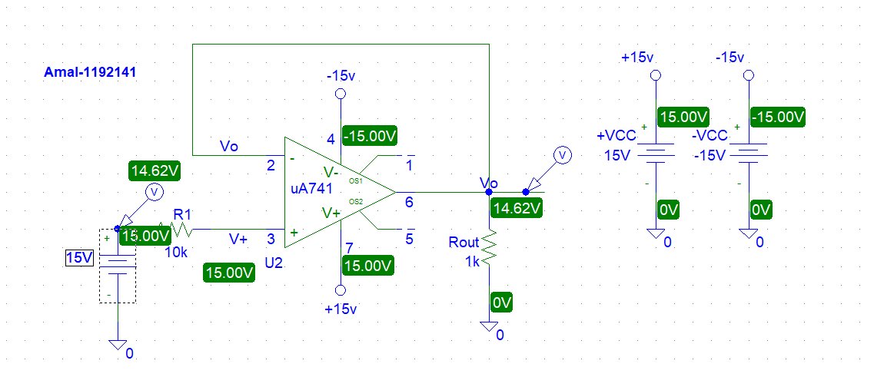

# Comparator Application:

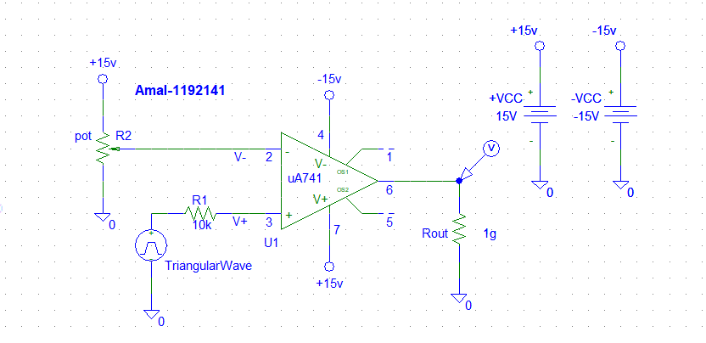

* + Vsat due to 2 VP-P dc reference and we set of potentiometer set =2,as show :



* -Vsat due to 2 VP-P input dc reference and we set of potentiometer set =759m,as show:



* Square wave output ( 2 VP-P input ),as show:



* When V+ > V- then we got Vsat , and when V +<V- we got –Vsat, We see that –Vsat is got when Vref = 1,+Vsat is got when Vref=-1

# Integrator and Differentiator:

## Integrator:

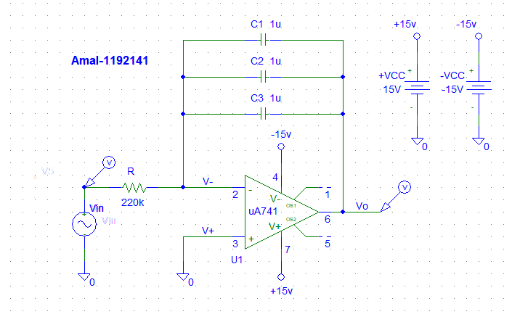

* The output is an integration of the input 🡪 the sine wave will be -cos wave.



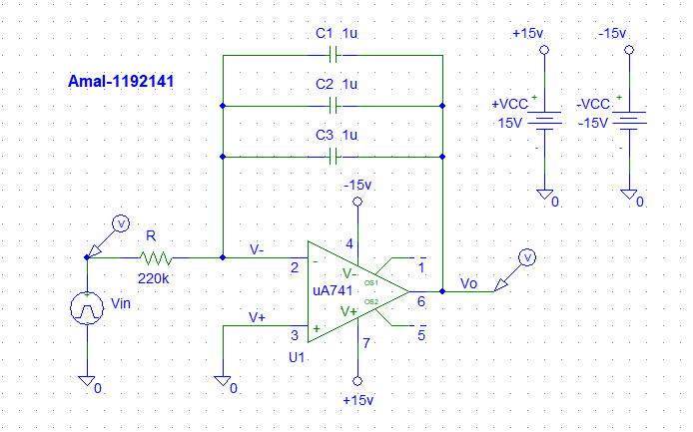



## Differentiator:

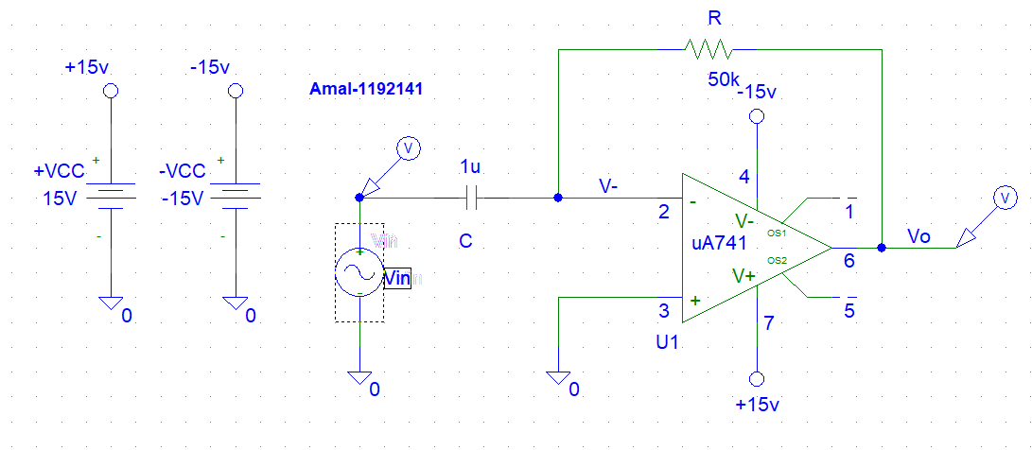



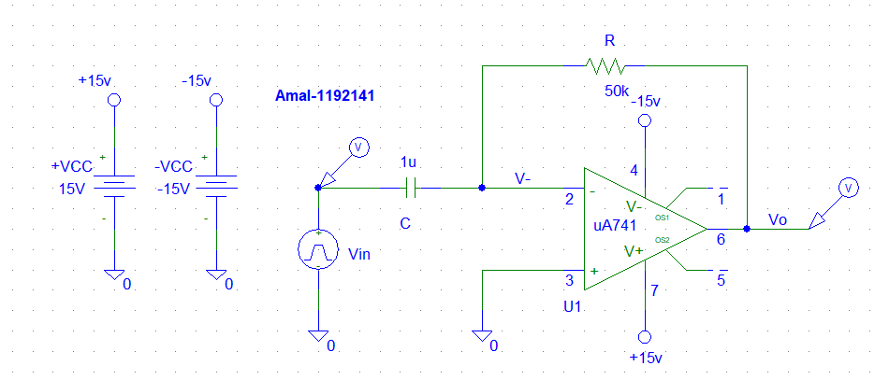



Note:

The output is a derivative of the input 🡪the square becomes Impulse function.

The output is an derivative of the input 🡪the triangular becomes square.

The output is an derivative of the input 🡪 the sin wave becomes cos

# To investigate the effect of adding hysteresis:

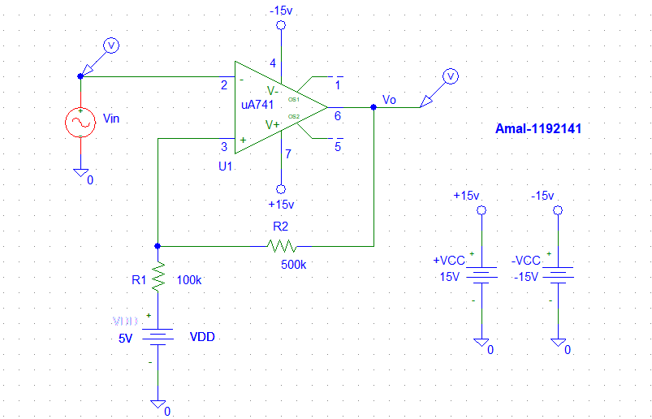

Vi(t) = 15 Vp-p sine wave with a freq. 1 kHz , then the output is shown on Vin & Vout:







To calculate the hysteresis: = |higher value – lower value |

Hysteresis as shown in simulation = 6.9 – 0.419 = 6.4

The levels of VIN where Vout changes its level is 6.9 volts, 419.795mv.

Calculated upper threshold =𝑉𝑐𝑐 − (𝑉𝑐𝑐 − 𝑉 + V𝑖𝑛) ∗ (𝑅2/𝑅2+𝑅1)) =7.5*0.833= 6.2475 volts.

Calculated lower threshold =𝑉 + V𝑖𝑛 ∗ 𝑅2/ (𝑅1 + 𝑅2) =15*0.833= 12.495 volts.

# Active Clipping Circuit:

• Clipped output due to certain input voltage:

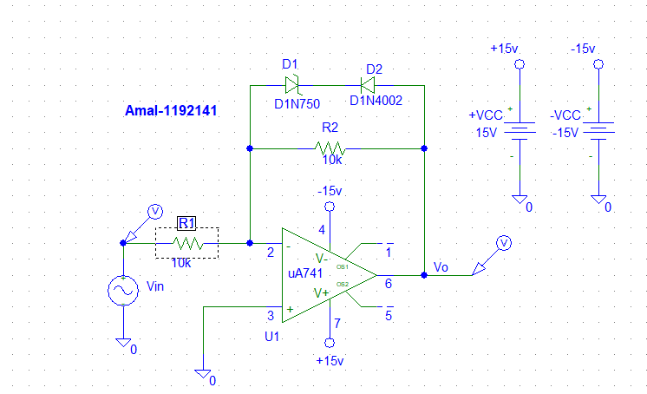

Vin & Vout , when Vin is 15V amplitude and frequency 1Hz :



* Clipped output after reversing the diode:

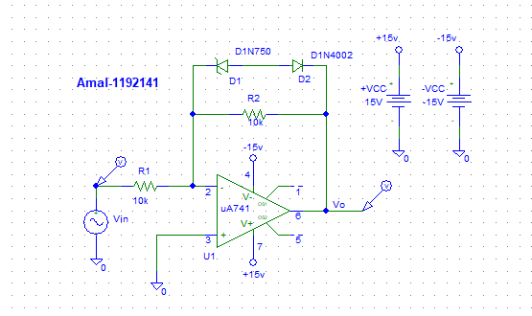

Vin & Vout , when both diodes are reversed:

